

**ENSE 471 -** [**User Interface Programming**](https://urcourses.uregina.ca/course/view.php?id=13770)

**Professor: Tim Maciag**

**Milestone 1.1 - Prep and Analysis**

**Date: January 16, 2019**

**Group Name: UserPro**

**Group Members: Han Gao, Azeezat Lawal, Mansi Patel, Muhammad Ishraf Shafiq Zainuddin**

**Github URL:** [**https://github.com/zainshafiq/User-Interface-Programming-Human-Centered-Design-**](https://github.com/zainshafiq/User-Interface-Programming-Human-Centered-Design-)

**Table of Contents**

**Purpose** **3**

**University of Regina Engineering** **4**

**University of British Columbia Engineering** **8**

**MIT School of Engineering** **12**

**University of Alberta** **16**

#### 

#### **Purpose**

The focus of this analysis is on the overall user experience (utility, usability, desirability) of the design (controls/layout/etc.) and associated page content of the Engineering faculty websites of the University of Regina, University of British Columbia, Massachusetts Institute of Technology and the University of Alberta. Multiple customer viewpoints were considered in the analysis, and the target customers include future students, current students, parents, alumni, etc.

We analyzed the different aspects of each website that was liked as well as what could be done better for each one.

#### **University of Regina Engineering**

<https://www.uregina.ca/engineering/>

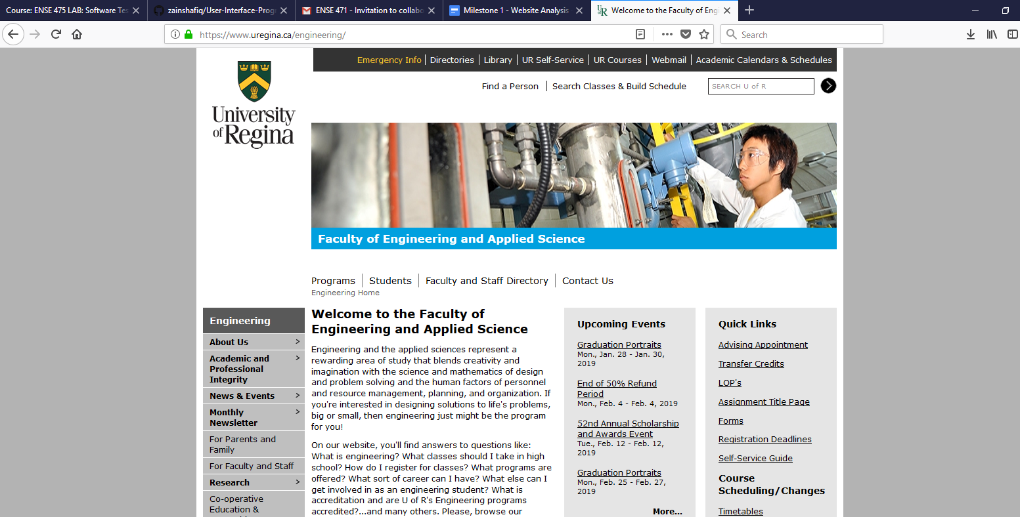

**Future Student**

* Utility (perceived usefulness) – High, it shows all the different categories on home page, can easily find what they want by quick looking through the webpage
* Usability
  + Learnability - good layout that is an inline list on the mid-top of the page. Its shows which part that the users want to go through
  + Efficiency - once clicked the link, content will dynamically show in the middle, instead of jump to another page, this can increase efficiency by reducing the response time used to open a new webpage. Some quick links can be found on the right side also can increase users efficiency.
  + Memorability – Low
  + Errors – some links does not work
* Desirability - layout for the whole page that works so badly. First of all, there are a lot of blank area on both sides that in every pages, it looks like the page is design for the mobile devices or any devices with vertical screen, it should be better adaption for every kind of screen. Secondly, the color of the pages is too simple, it makes user feel boring, it can not drive any users motivation to go deeper to look through the website. Thirdly, less visual feedback in pages, almost all the content are only displayed by text, less of user interaction.
* Overall Experience-Boring

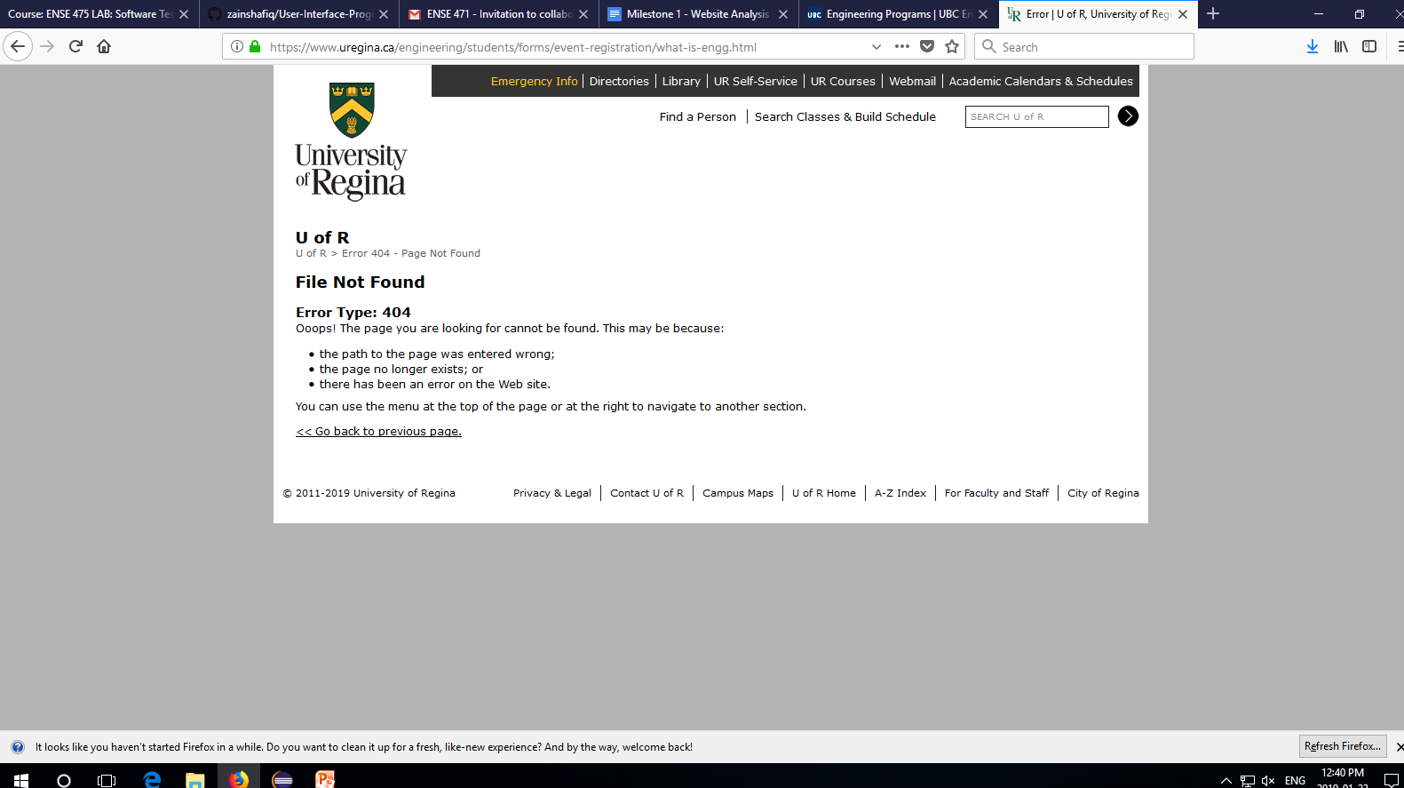

**Current Student**

* Utility (perceived usefulness) - High, it shows all the different categories on home page, can easily find what they want by quick looking through the webpage.
* Usability
  + Learnability - good things in the layout there is an inline list on the mid-top of the page. Its shows which part that the users want to go through
  + Efficiency - once clicked the link, content will dynamically show in the middle, instead of jump to another page, this can increase efficiency by reducing the response time used to open a new webpage. Some quick links can be found on the right side also can increase users efficiency.
  + Memorability - High.
  + Errors - some links does not work
* Desirability – Quick way to search for information.
* Overall Experience- Fast and convenient.

**Alumni**

* Utility (perceived usefulness) - High,it shows all the different categories on home page, can easily find what they want by quick looking through the webpage.
* Usability
  + Learnability - good things in the layout there is an inline list on the mid-top of the page. Its shows which part that the users want to go through.
  + Efficiency - once clicked the link, content will dynamically show in the middle, instead of jump to another page, this can increase efficiency by reducing the response time used to open a new webpage. Some quick links can be found on the right side also can increase users efficiency.
  + Memorability - Low.
  + Errors - some links do not work.
* Desirability - the layout for the whole page works so badly. First of all, there are lots of blank area on both sides that in every page, it looks like the page is designed for mobile devices or any device with a vertical screen. It should have better adaption for all types of screens. Secondly, the color of the pages is too simple, it makes user feel bored, and it does not give users motivation to go deeper to look through the website. Thirdly, less visual feedback in pages, almost all the content are only displayed by text, less of user interaction.
* Overall Experience-Boring

**Parents**

* Utility (perceived usefulness) - High,it shows all the different categories on home page, can easily find what they want by quick looking through the webpage.
* Usability
  + Learnability - good things in the layout there is an inline list on the mid-top of the page. Its shows which part that the users want to go through.
  + Efficiency - once clicked the link, content will dynamically show in the middle, instead of jump to another page, this can increase efficiency by reducing the response time used to open a new webpage. Some quick links can be found on the right side also can increase users efficiency.
  + Memorability - High.
  + Errors – broken links.
* Desirability – Easy to find the information in the web page.
* Overall Experience- Fast and convenient.

**Colleagues not in the Engineering Faculty**

* Utility (perceived usefulness) - High, it shows all the different categories on home page, can easily find what they want by quick looking through the webpage.
* Usability
  + Learnability - good things in the layout there is an inline list on the mid-top of the page. Its shows which part that the users want to go through.
  + Efficiency - once clicked the link, content will dynamically show in the middle, instead of jump to another page, this can increase efficiency by reducing the response time used to open a new webpage. Some quick links can be found on the right side also can increase users efficiency.
  + Memorability - High.
  + Errors – broken links.
* Desirability - the layout for the whole page works so badly. First of all, there are lots of blank area on both sides that in every page, it looks like the page is designed for mobile devices or any device with a vertical screen. It should have better adaption for all types of screens. Secondly, the color of the pages is too simple, it makes user feel bored, and it does not give users motivation to go deeper to look through the website. Thirdly, less visual feedback in pages, almost all the content are only displayed by text, less of user interaction.
* Overall Experience- Fast and convenient.

#### **University of British Columbia Engineering**

<https://engineering.ubc.ca/>

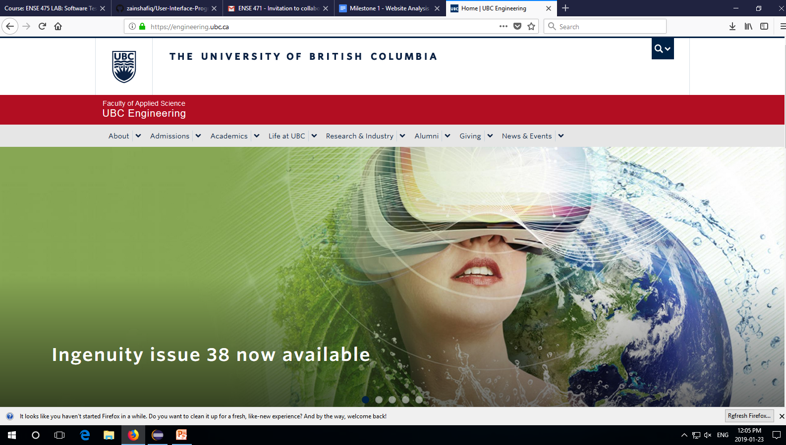

**Future Student**

* Utility (perceived usefulness) - As a future student, the website is useful to get information about the UBC Engineering faculty and provides different ways to attain different, useful information.
* Usability
  + Learnability - The website is easy to learn how to use and the user is able to quickly grasp how to navigate the website and get the information they need.
  + Efficiency - The website makes good use of space and there is no unnecessary information floating around.
  + Memorability - From the perspective of a future student, there are only two important menus to go through and coming back to the website, it was easy to remember where the important information is and how to continue navigating through the website. Everything important for a future student is stated clearly.
  + Errors - Little to no error, very little room for mistakes and easy to fix them when it happens just by clicking the back button.
* Desirability - This website is very pleasurable to use, through the view of a future student. Every necessary part is straightforward and the information is useful. The way there a lots of images and interactive icons makes for a better, more interesting look through.
* Overall Experience - Information was easily accessed and straightforward. Very good source of important information.

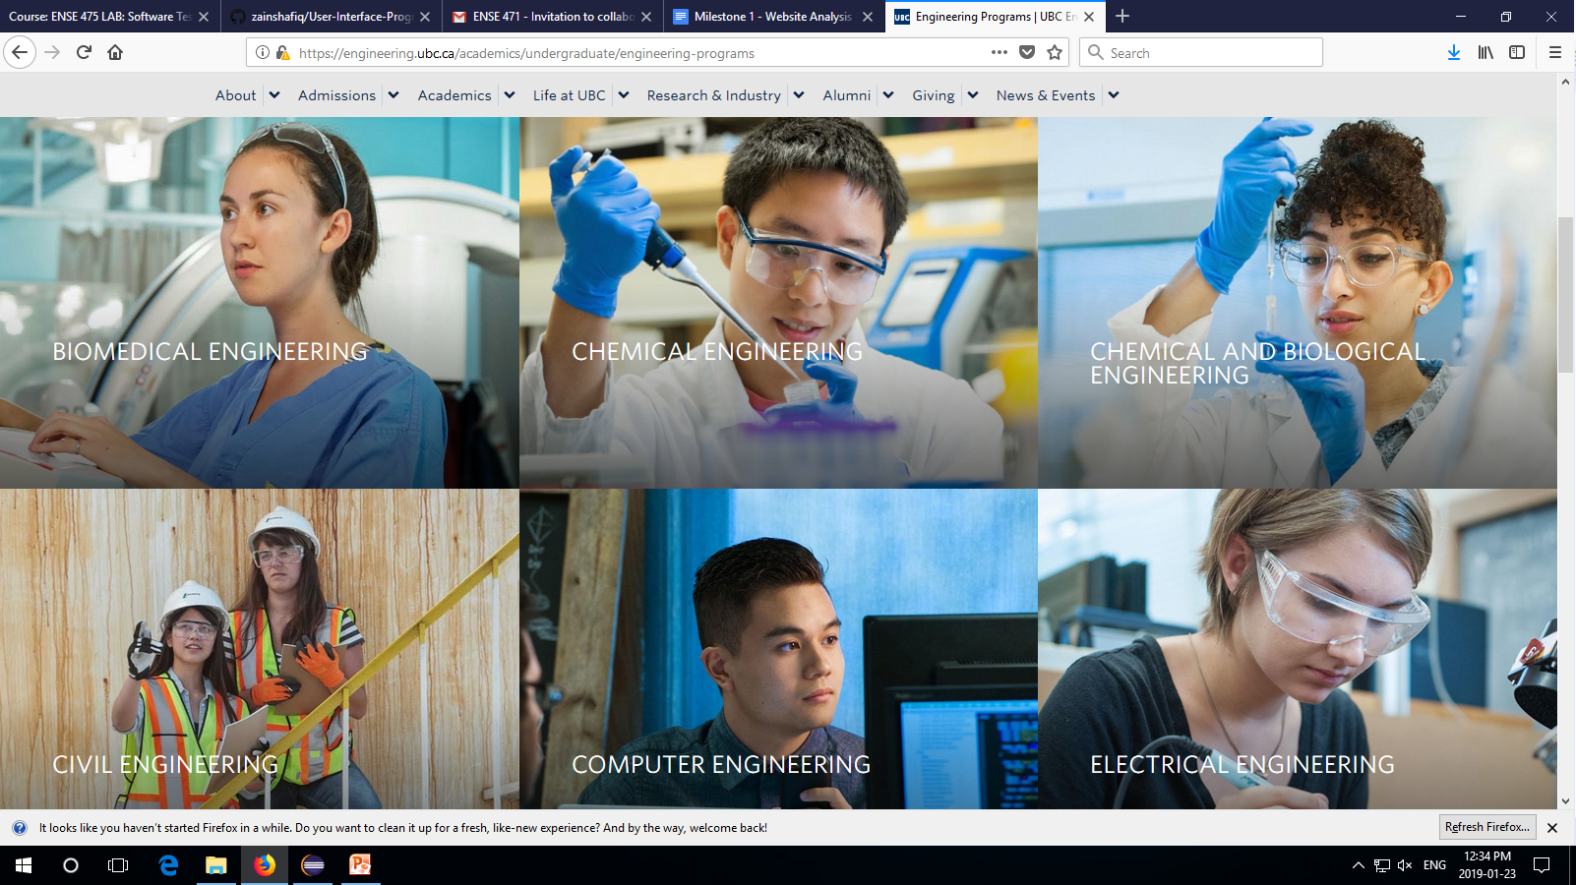

**Current Student**

* Utility (perceived usefulness) - The website is not as important for current students as it only has some necessarily information. There is no specific section that is highlighted as current students, and it contains a lot of information that current students would already know. However, when the Contact Student Services menu is clicked under the Undergraduates section in Admissions, it leads to a different site which has a lot of forms necessary for all students.
* Usability
  + Learnability - Current students would have already used the website but again, it is not difficult to maneuver.
  + Efficiency - The events and news drop-down is relevant to current students and it is an efficient use of the website.
  + Memorability - There is high memorability; it is easy to get back into using the website after exiting for a period.
  + Errors - Little to no error, very little room for mistakes and easy to fix them when it happens just by clicking the back button.
* Desirability - For a current student, the website is a little desirable, and only useful if you know where to look. It does contain much needed information a current student would need but it is not easy to find the page.
* Overall Experience - Good aesthetics, but only a hidden small section is needed by current students. There should be an expansion on this small section and it should be made more obvious.

**Alumni**

* Utility (perceived usefulness) - Very useful for the engineering alumni and all the information they may need to stay connected to the university.
* Usability
  + Learnability - It is not hard to learn for the alumni. On the main menu of the engineering page, it is very clear where an alumni should click when navigating the website.
  + Efficiency - Very easy and fast to use and scan through information.
  + Memorability - There is very high memorability, as the menu is easy to see and the information is clear.
  + Errors - Very little room for errors; straightforward.
* Desirability - This is good for the alumnus who is interested in staying connected to the going-ons in the university. They can get most of the information they need from the website and they would only the more esoteric information.
* Overall Experience - A nice way to relive the memories of the past at the school. There are pictures and information on reunions and events.

**Parents**

* Utility (perceived usefulness) - Good for information seeking parents on a good school for their children, especially the future students. May not be as useful or easy to navigate for parents looking for more information on what their current students are doing, or looking for information to assist their current students.
* Usability
  + Learnability - Again, the website is easy to learn for the most part, however, a parent may not know the first place to start their search. The menu is helpful on where to go.
  + Efficiency - Efficient in the sense that it contains useful information, however there is no special menu selection for parents.
  + Memorability - Easy to remember when the website has been used before; high memorability.
  + Errors - Parents looking for information on the website may be prone to errors at first, as they try to navigate the website.
* Desirability - The website is a good source of information for parents to have on hand in case they are not able to reach someone personally. However, it is not a really necessary source for parents.
* Overall Experience - Good, perhaps there can be a clear menu for the information parents may need, i.e. frequently asked questions.

**Colleagues not in the Engineering Faculty**

* Utility (perceived usefulness) - Not really useful for colleagues that are not involved in the engineering faculty. Only useful to know events that may be enjoyable in the engineering faculty that may also be enjoyable for the colleague.
* Usability
  + Learnability - Easy to learn but is not pressing information.
  + Efficiency - Efficient to navigate.
  + Memorability - Easy to remember, but the information wouldn’t necessarily stick because the student doesn’t need the information.
  + Errors - There are no noticeable errors.
* Desirability - It is an aesthetically pleasing page but the information is not necessary for this individual.
* Overall Experience - Nice to see, not important for this stakeholder.

#### **MIT School of Engineering**

<https://engineering.mit.edu/>

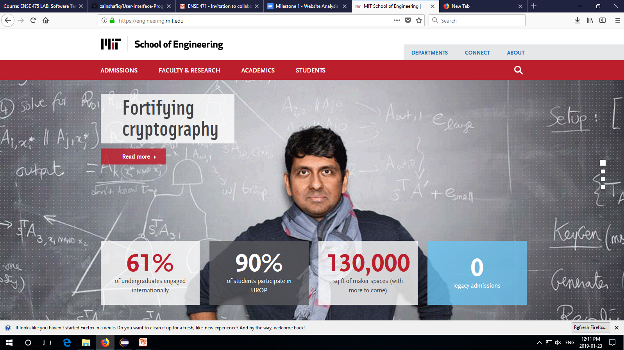

**Future Student**

* Utility (perceived usefulness) - Very good experience especially for future students that will be looking for informations about the school and what is it all about. Every informations that are deem necessary are being given in the homepage with menu bar and hyperlinks provided for a more details experience. Every faculty has its own webpage with their own identity/design which can be find as unique and somewhat interesting.
* Usability
  + Learnability - It is easy to use, navigate even with its complex yet interesting CSS design.
  + Efficiency - Easy to navigate throughout the page, quick and efficient to get one information.
  + Memorability - Every sets of informations are being provided with guidelines (menus, hyperlinks) if extra/detailed infos are needed.
  + Errors - Less, close to none. (updated regularly)
* Desirability - More improvement can be made in the future but with its interesting design, straightforward information and efficient navigation, the experience are very good.
* Overall Experience - The designs are captivating especially with their individual web page for different program without neglecting focus on important details and informations.

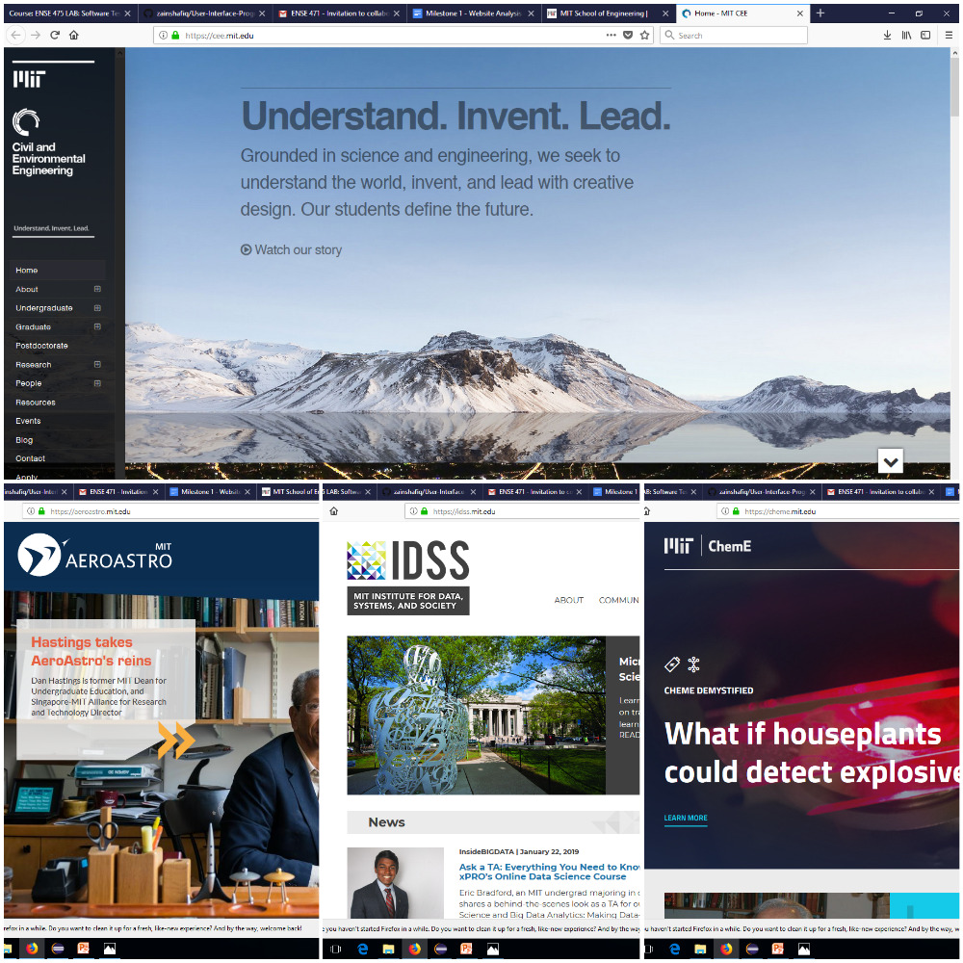

**Current Student**

* Utility (perceived usefulness) - Except for the news and general infos, the web page seems like only useful for a future students or parents since the currents students will have to navigate to its own program web page for necessary informations.
* Usability
  + Learnability - It is easy to use, navigate even with its complex yet interesting CSS design.
  + Efficiency - The school of engineering web page are easy to navigate but it's a different story when you go to the different program web page (some of them are easy and some are complex for navigation)
  + Memorability - Every sets of informations are being provided with guidelines (menus, hyperlinks) if extra/detailed infos are needed.
  + Errors - Less, close to none for general engineering web page. Some errors in individuals web page.
* Desirability - The design, straightforward information and efficient navigation makes the experience very good for the general engineering web page. Unfortunately, some of the individual programs web page need to be improve more especially for their messy design and much confusing navigation.
* Overall Experience - The designs are captivating for their individual program but unfortunately they do not go hand to hand with the info and navigation (ease of use).

**Parents**

* Utility (perceived usefulness) - Very good experience especially for parents that will be looking for informations about the school and what is it all about. Every informations that are deem necessary are being given in the homepage with menu bar and hyperlinks provided for a more details experience.
* Usability
  + Learnability - It is easy to use, navigate even with its complex yet interesting CSS design.
  + Efficiency - Easy to navigate throughout the page, quick and efficient to get one information.
  + Memorability - Every sets of informations are being provided with guidelines (menus, hyperlinks) if extra/detailed infos are needed.
  + Errors - Less, close to none.
* Desirability - More improvement can be made in the future but with its interesting design, straightforward information and efficient navigation, the experience are very good.
* Overall Experience - The designs are captivating especially with their individual web page for different program without neglecting focus on important details and informations.

**Alumni**

* Utility (perceived usefulness) - Good experience for alumni to find necessary informations that are deem necessary.
* Usability
  + Learnability - It is easy to use, navigate even with its complex yet interesting CSS design.
  + Efficiency - Easy to navigate throughout the page, quick and efficient to get one information.
  + Memorability - Every sets of informations are being provided with guidelines (menus, hyperlinks) if extra/detailed infos are needed.
  + Errors - Less, close to none for general engineering web page. Some errors in individuals web page.
* Desirability - The design, straightforward information and efficient navigation makes the experience very good for the general engineering web page. Unfortunately, some of the individual programs web page need to be improve more especially for their messy design and much confusing navigation.
* Overall Experience - The designs are captivating especially with their individual web page for different program without neglecting focus on important details and informations.

**Colleagues not in the Engineering Faculty**

* Utility (perceived usefulness) - Interesting and captivating design. User friendly.
* Usability
  + Learnability - It is easy to use to navigate to find necessary information
  + Efficiency - Easy to navigate throughout the page, quick and efficient
  + Memorability - Every sets of informations are being provided with guidelines (menus, hyperlinks) if extra/detailed infos are needed.
  + Errors - None.
* Desirability - More improvement can be made in the future but with its interesting design, straightforward information and efficient navigation, the experience are very good.
* Overall Experience - The designs are interesting and nice (“Ouh wow, I like it better than our university web page” - Andy Zheng, U of R CS Major).

#### **University of Alberta**

<https://www.ualberta.ca/engineering>

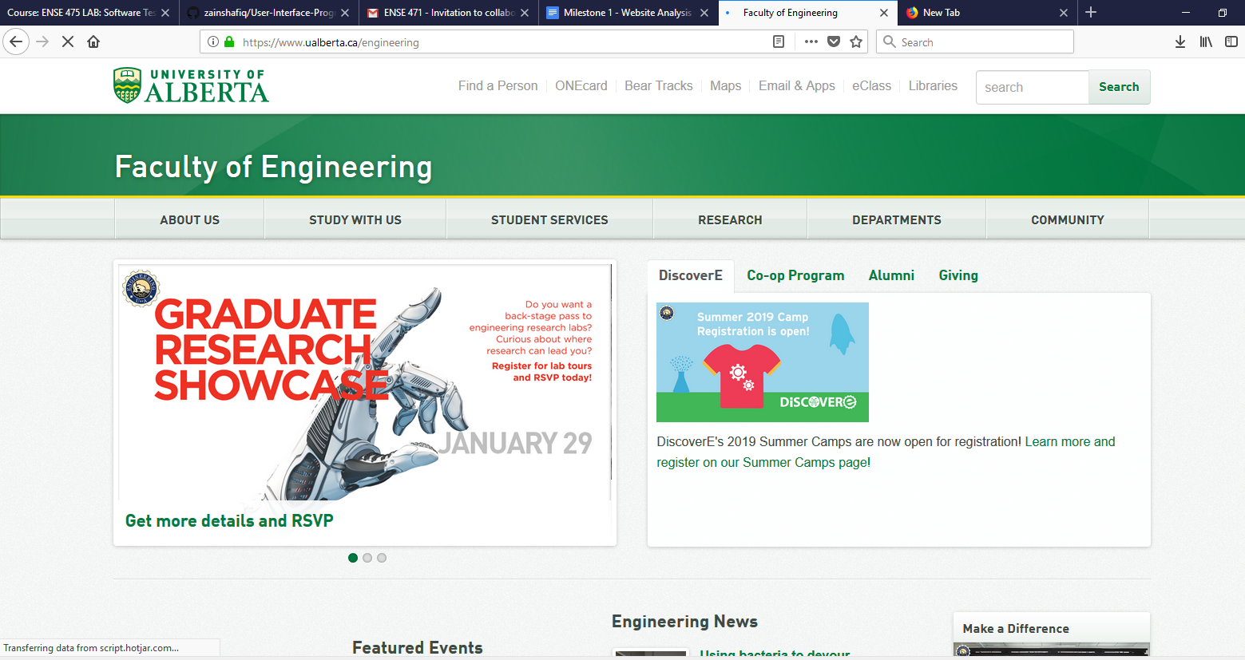

**Future Student**

* Utility - The engineering website of University of Alberta seems to be an useful website for the students. Students can get all the necessary information related to certain program. It is very easy to navigate the necessary information. Well described negaviation bar.
* Usability
  + Learnability - the webpage is easy to use and can easily navigate through all the sections of the webpage. Also user can easily go back to its original page as it has good signifiers
  + Efficiency - The layout of the page seems to be an interesting. The informations available on the main page of engineering website is not properly laid out. It is not easy to recognized the information
  + Memorability - As a future student perspective, it is very easy to go through the the section as there is separation section available for the future to find the important information. It is very easy to memorise the way of going back to the main page
  + Errors - could not find any errors on webpage
* Desirability - need to focus on the layout of the page, font type and color. Overall the experience was very good and desirable design of the webpage
* Overall Experience - It is easy to use and fast as well able to find all the necessary information.

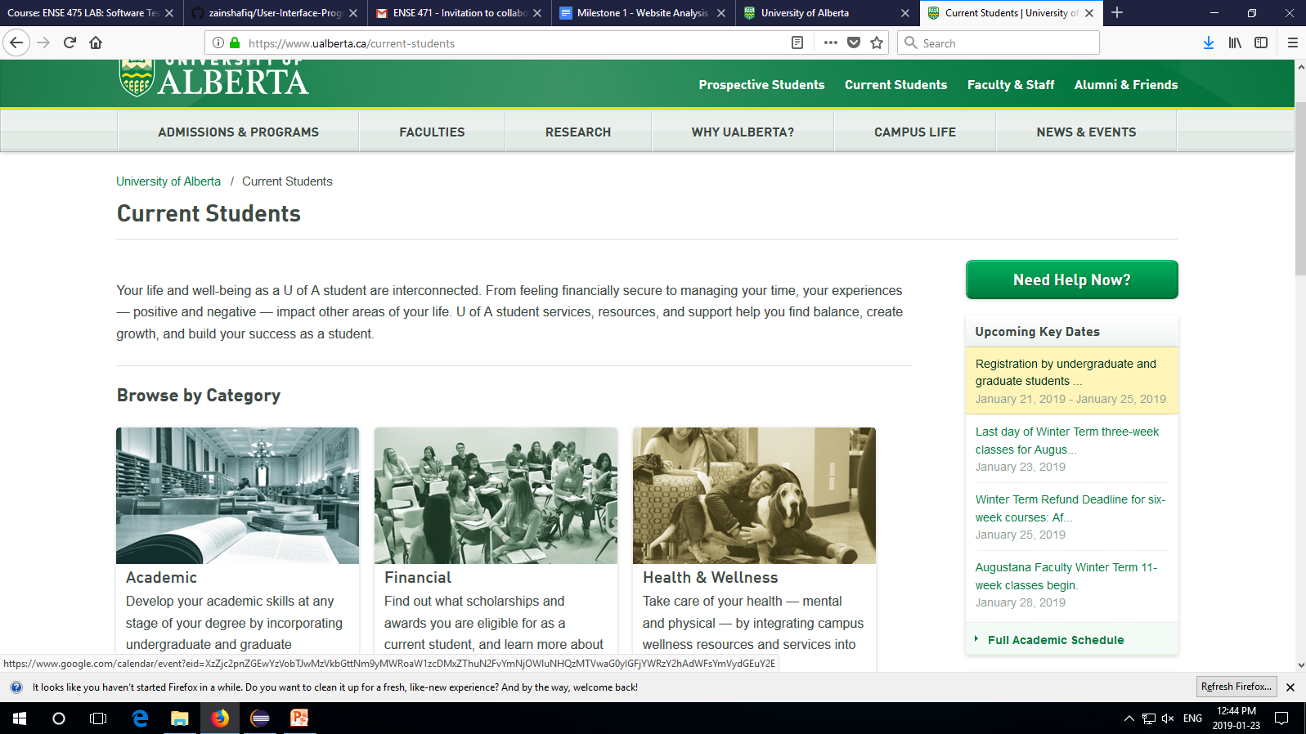

**Current Student**

* Utility (perceived usefulness) - if we see as a current student perspective, it is quite good for the current students. The webpage is very useful to for the current student as it provides all the important information like student resources, news and events, academic advisors information etc.
* Usability
  + Learnability - The website is easy to learn how to use and the user is able to quickly learn how to navigate the website and get the information they need.
  + Efficiency - it is very efficient school website as it is easy to find all important and necessary information as well as it is easy to navigate
  + Memorability - it has high memorability as it is easy to use
  + Errors - could not able to find any error
* Desirability - For the current students, the website is desirable as much needed informations are available on the website. And being a current students, the informations are very useful
* Overall Experience - need to focus on the layout of the page, font type and color. Overall the experience was very good and desirable design of the webpage

**Parents**

* Utility (perceived usefulness) - Very good experience especially for parents that will be looking for informations about the school and what is it all about.
* Usability
  + Learnability - it might be little difficult for a parent to find the information at first look. But after using the website bit more, they can find information easily
  + Efficiency - easy to navigate through the sections, quick and easy to follow
  + Memorability - it has high memorability, Easy to remember and easy to go through all the sections
  + Errors - No errors detected
* Desirability - Easy to find the information in the web page, it is desirable
* Overall Experience - it is easy to search and it is convenient to use. Overall good experience

**Colleagues not in the Engineering Faculty**

* Utility (perceived usefulness) - easy to find the informations and user friendly design
* Usability
  + Learnability - It is easy to use to navigate to find necessary information.
  + Efficiency - Easy to navigate throughout the page, quick and efficient
  + Memorability - it is very efficient school website as it is easy to find all important and necessary information as well as it is easy to navigate
  + Errors - No errors detected
* Desirability - Easy to find the information in the web page, it is desirable
* Overall Experience - it is easy to search and it is convenient to use. Overall good experience

**Alumni**

* Utility (perceived usefulness) - Very useful for the engineering alumni and all the information they may need to stay connected to the university.
* Usability
  + Learnability - It is not hard to learn for the alumni. On the main page of the engineering website, there is a section for the alumni to go through where they can find all necessary information
  + Efficiency - it is very efficient school website as it is easy to find all important and necessary information as well as it is easy to navigate
  + Memorability - There is very high memorability, as the menu is easy to see and the information is clear
  + Errors - Very little room for errors
* Desirability - For the Alumni, the website is desirable as much needed informations are available on the website and is to good to be stayed connected
* Overall Experience - A nice way to relive the memories of the past at the school. There are pictures and information on reunions and events.